INTERNSHIP WEEKLY ASSIGNMENT PROCEDURES
(as of 8/29/14)

Due Every Saturday by Midnight
  - Personal Reflection – Turnitin.com
  - Will be available on the Thursday of each week.
  - Deadline: Monday by 7:25am (50%)
  - Class code – 8410068
  - Password - password

Due Every Tuesday by 2:15 pm*
  - Timesheet – Red Tray in Room 109B
    - 50% if turned in by Wednesday at 2:10pm
EXAMPLE WEEK:
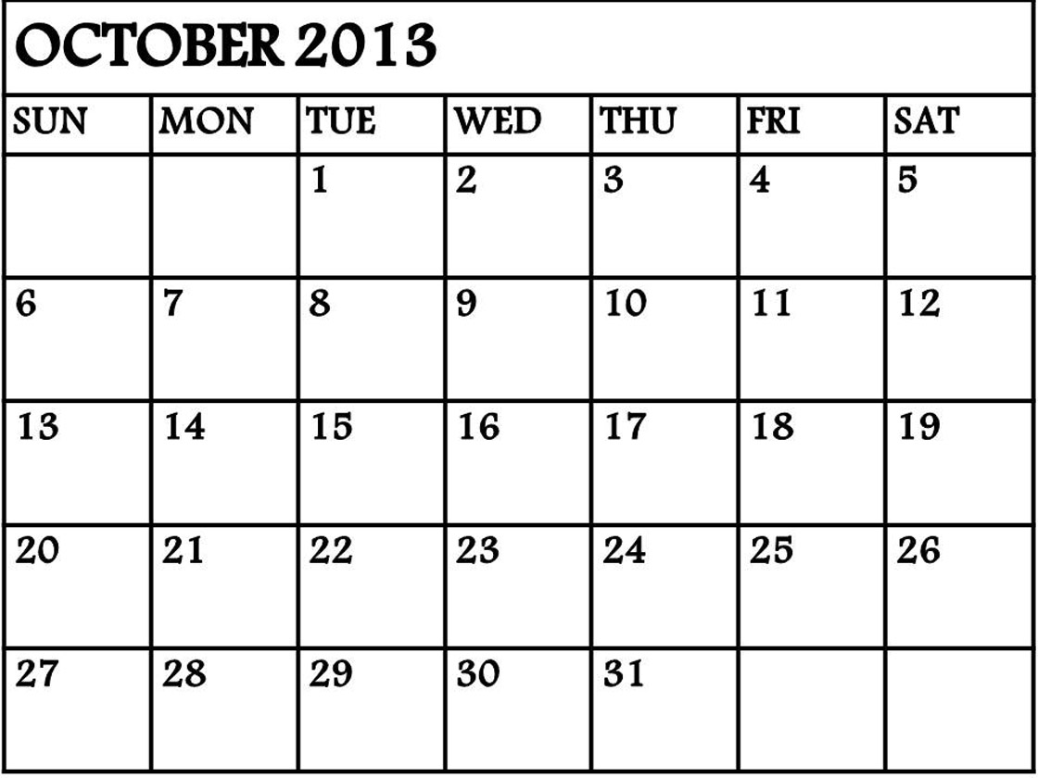
Due Date: Reflection
WORK
Due Date: Reflection
Due Date: Timesheet

